DP1 2020-2021

Document of System Design

Tuvi’s Casino Project

<https://github.com/gii-is-DP1/dp1-2020-g1-07>

Members:

* David Barragán Salazar
* Beatriz Beltrán Álvarez
* Daniel Caro Olmedo
* Antonio González Gómez
* Daniel Muñoz Heredia
* Vicente Soria Vázquez

Tutor: Bedilia Estrada

# GROUP G1-07

## Version 1

26/10/2020

## Version history

|  |  |  |  |
| --- | --- | --- | --- |
| Date | Version | General description | Sprint |
| 06/01/2021 | V1 | * Document creation. | 3 |
| 7/01/2021 |  | * Added part of the design decisions | 3 |
|  |  |  | 3 |
| 25/01/2021 |  | * Minor changes | 4 |
|  |  |  |  |

Contents

GROUP G1-07 1

Version 1 1

Version history. 2

Date 2

Introduction 5

UML Diagrams: 6

Domain Diagram 6

Layers Diagram 7

Design and architectonic patterns applied 8

Patterm: Proxy (Front Controller) 8

Type: Dessign 8

Application context 8

Pattern: Model View Controller (MVC) 11

Type: Architectonic 11

Application context 11

Clases o paquetes creados 12

Design decisions 15

Decision 1: Using javascript to get the element id to complete the edit url 15

Problem description: 15

Justification of chosen solution 15

Decision 2: Tests in controllers and services 15

Problem description: 15

Justification of chosen solution 16

Decision 3: Managing the heritage relation from “Employee” entity. 16

Problem description: 16

Justification of chosen solution 17

Decision 4: Validation subsequent to @Valid in 17

Problem description: 17

Justification of chosen solution 18

Decision 5: Complex filters for database queries. 19

Problem description: 19

Justification of chosen solution 19

Decision 6: Showing incomes from slot machines. 19

Problem description: 19

Justification of chosen solution 20

Decision 7: Values from selectors that depend from others. 20

Problem description: 20

Decision 8: Showing client gains from certain weeks. 21

Problem description: 21

**PHOTOGRAPHY’S INDEX**

Photography 1 - Domain diagrams 6

Photography 2 - Method createEvent (used in Proxy pattern) 8

Photography 3 - Method processUpdategameForm (used in Proxy pattern) 9

Photography 4 - Method eventsByDay (used in Proxy pattern) 9

Photography 5 - File jsp 10

Photography 6 - Casinotable Entity 11

Photography 7 - Method initUpdateCasTbForm 11

Photography 8 - Casinotables’ view 11

Photography 9 - Entities 12

Photography 10 - CasinotableService is calling to CasinotableRepository 13

Photography 11 - Services 13

Photography 12 - Querys in CasinotableRepository 13

Photography 13 - Controllers, Validators and Formatters 14

Photography 14 - Jsp files 14

# Introduction

Tuvi’s Casino is a gambling games center which has among their facilities services such as a restaurant, where visitors can have whatever meal they desire in the moment, some show scenarios, where artists perform their shows on a daily basis, and a lot of gaming tables and slot machines

Due to all this, the management of this casino without a proper website is a hard task in day-to-day.

The goal of our Project is to develop a website with which the admins of Tuvi’s Casino will be able to successfully manage their business.

This website is going to contain features such login for each different type of user (admin, worker, and client). Depending on the kind of user that is logged on the website, it will able him to manage different things.

If the user who is logged is a client, the website will show information about his income record, the games he can play and the shows that are going to take place in the casino. Also, the client will be able to reserve table in the Casino’s restaurant using this website.

If the user who is logged is an employee, the website will able him to check their shift and where is he going to work, depending on the employee type (this types are described in detail in this document).

In closing, if the user who is logged on the website is an admin, the website will show all the information about the casino, and the admin will be able to manage features such as the employees’ shifts or the events distribution and the addition of tables or slot machines.

# UML Diagrams:

## Domain Diagram

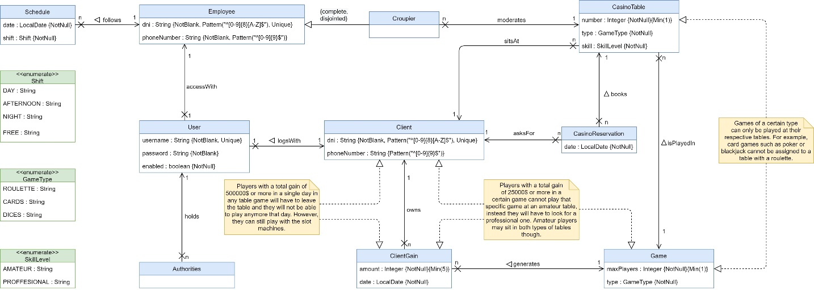

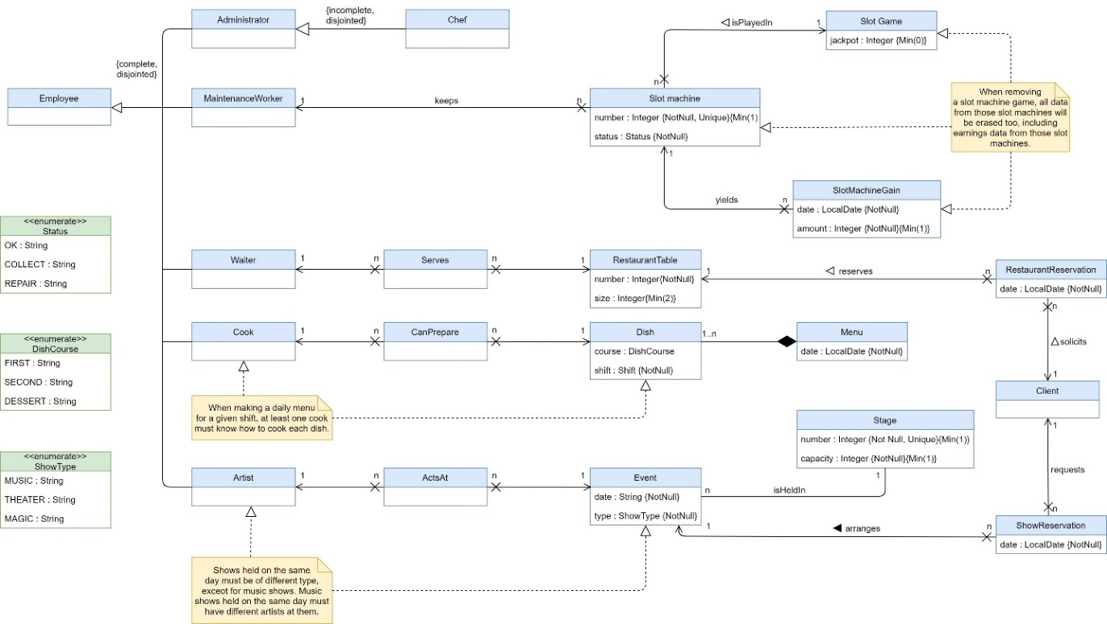

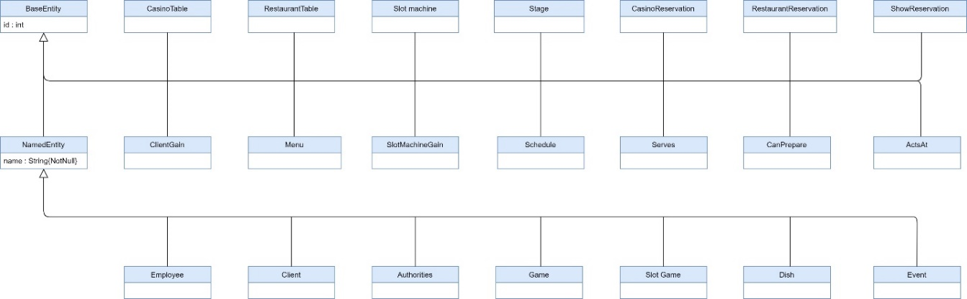

Photography - Domain diagrams

## Layers Diagram

<https://github.com/gii-is-DP1/dp1-2020-g1-07/blob/master/documents/3rd%20Sprint/DiagramaDeCapas.png>

# Design and architectonic patterns applied

## Pattern: Proxy (Front Controller)

### Type: Dessign

### Application context

We use the proxy design pattern (called Front Controller in Spring). What we do with this is generate a component (the proxy) that takes care of "intermediate" tasks without directly communicating two components. In our case would be the Dispatcher Servlets in charge of fulfilling this function.

The Dispatcher Servlet, complying with the MVC architectural pattern, takes the requests from the page (view) and is responsible for acting as an intermediary between the components of MVC. To do this, first, upon receiving the request, proceeds to make the Handler Mapping. In the mapping, we use annotations of the form:

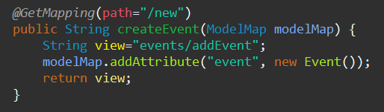

Photography - Method createEvent (used in Proxy pattern)

“@getMapping”, to specify which route the system should follow. After mapping, the servlet contacts the driver. The driver takes the HTTP/HTML information and extracts it from String's java objects. To do this, Spring provides us with the BindingResult tool.

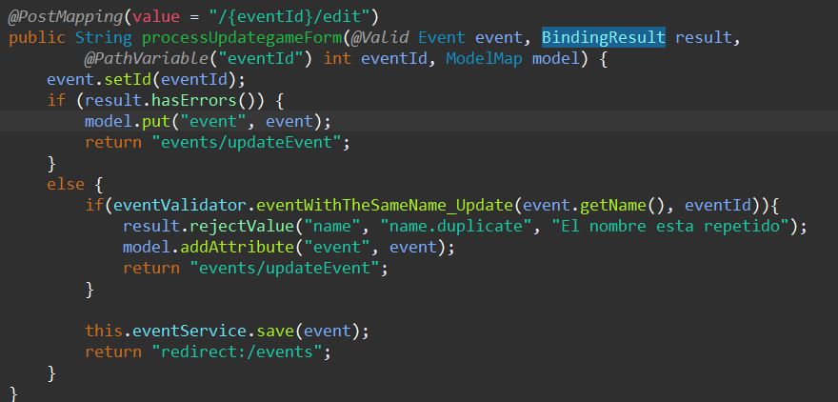

Photography - Method processUpdategameForm (used in Proxy pattern)

After this, the Servlet receives from the controller: the view to be used and the model (Model Map) to be used in it.

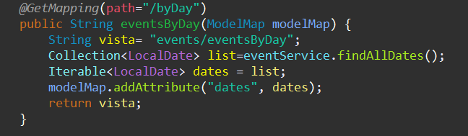

Photography - Method eventsByDay (used in Proxy pattern)

Once redirected, before reaching the view, a View Resolver is processed, whose task is to specify what type of view we are going to reach. In our case, we work with JSP's. Finally, the Servlet (our proxy) is responsible for sending the ModelMap to the view and printe it. When using JSP, we use the template view, practically HTML, with JSP elements (representation of model attributes).

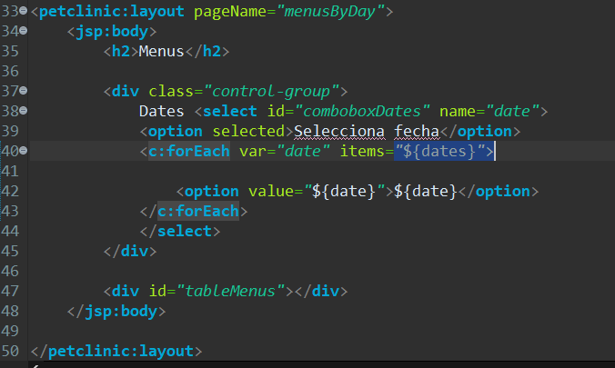

Photography - File jsp

## Pattern: Model View Controller (MVC)

### Type: Architectonic

### Application context

Another pattern that we apply in the application is MVC (due to the characteristic of the framework that we use, Spring) implementing packages that correspond to model, views and controllers.In the application, the model corresponds to entities created that provide information on their attributes, in addition to methods that allow obtaining data when showing them to the user through views or configuring them.

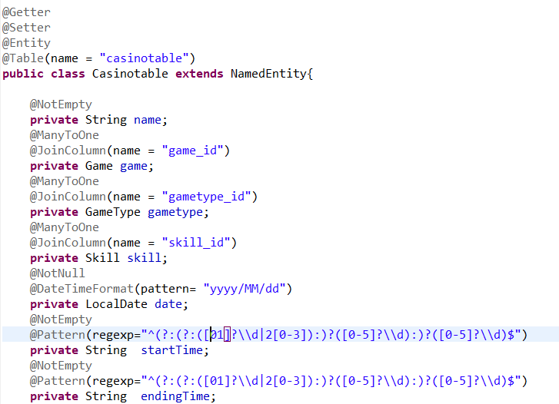

Photography - Casinotable Entity

Controllers are the part that allow the application to enter different views or other controllers, in addition to checking the data in validators and configuring data that is displayed.

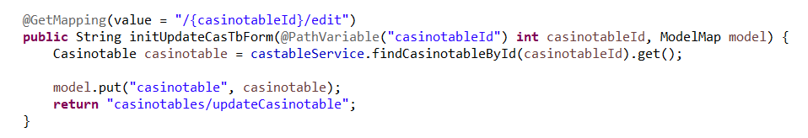

Photography - Method initUpdateCasTbForm

Once a controller leads to another view, this is displayed to the user, who can access to the different services of the application.

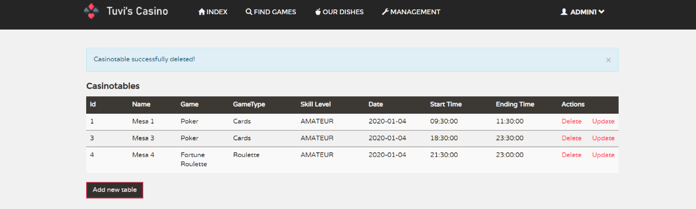

Photography 8 - Casinotables’ view

### Clases o paquetes creados

**PACKAGES | MODEL CLASSES**

As previously stated, entities represent the application model, being these classes in the package *Model inside the application.*

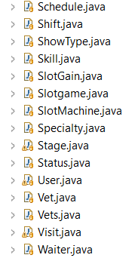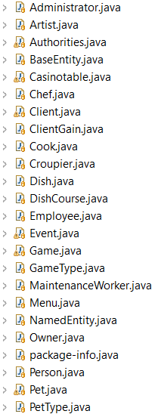

Photography - Entities

**PACKAGES | CONTROLLER CLASSES**

In the previous section we clarified that controllers use validators to verify the proper use of data that is configured in views, but other classes that allow to acquire information found in the database are also used.

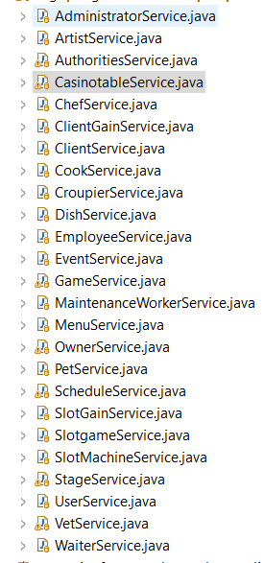In the first place, we will focus on *Service* and *Repository* packages, being these classes of the first package those that call the classes of the second.

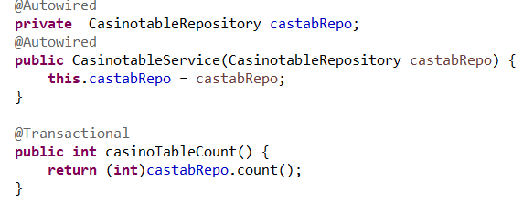

Photography - CasinotableService is calling to   
 CasinotableRepository

Photography - Services

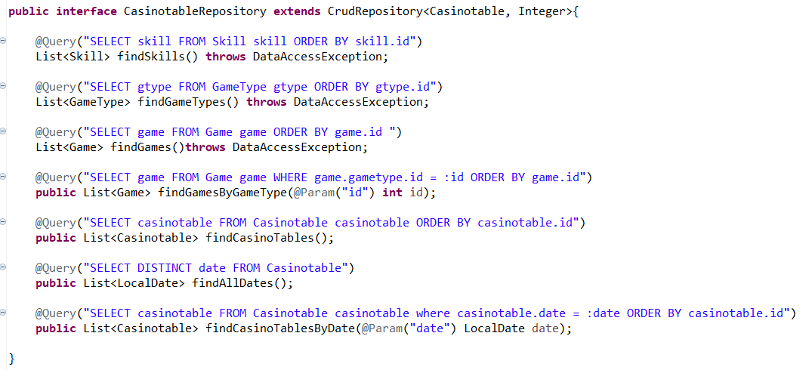

Photography - Querys in CasinotableRepository

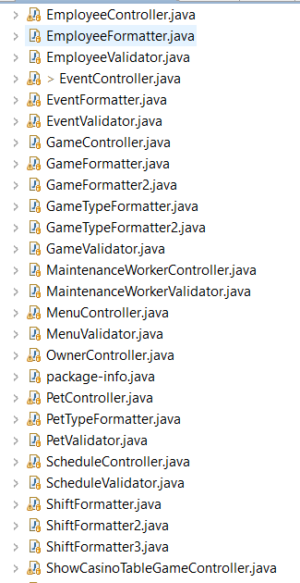Classes of *Service* package are used in controllers implemented in the *Web* package, where they also find validators that allow the verification of data.

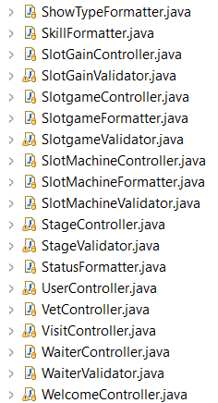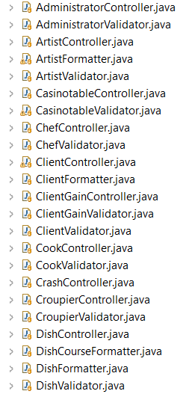

*Paquete Web, que contiene los controladores y los validadores*

Photography - Controllers, Validators and Formatters

**PACKAGES | VIEWS CLASSES**

For views we use different .jsp files that allow the user to see the content they prefer, as it was previously shown with the *“/casinotables”* view

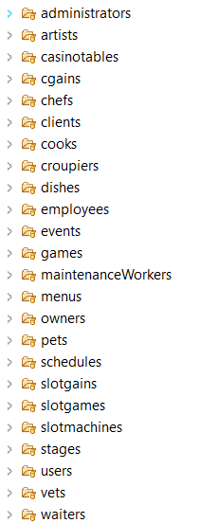

Photography - Jsp files

# Design decisions

## Decision 1: Using javascript to get the element id to complete the edit url

### Problem description:

We could not get the element id of the element that was described on the form

Solution 1.a: Examining the controller to get the element id

**Advantages:**

* It is contained on the controller

**Disadvantages:**

* Harder to code and takes more time

Solution 2.b: Using the javascript function getElementById into the update.jsp file to get the element id of the element, so we can add it in the edit url.

**Advantages:**

* This part of the code is contained in the jsp
* Easier to code and understand

**Disadvantages:**

* It is not included at the backend

### Justification of chosen solution

We consider that understanding and simplifying the code when it is possible is very important. That is because we have chosen the solution 2.b

## Decision 2: Not implementing validator tests

### Problem description:

When we began doing the controller tests we noticed that, at the same time, most of the tests were checking a correct functioning of validators along with the controllers they were attached with. So the question about if we should add additional tests only for the validators or not was raised.

*Solution 2.a:* Make brand new tests for validators classes.

**Advantages:**

* More validation.
* Everything is double checked.

**Disadvantages:**

* More code.
* Testing is repeated.
* Longer execution times due to having more tests.

*Solution 2.b:* Use the controller tests to also test the functions of the validators.

**Advantages:**

* Less and simpler code.
* All the components of a controller are tested in the same place.
* Less tests, so better performance.
* Everything is still checked.

**Disadvantages:**

* There is no double-checking (we only tests the validators once).

### Justification of chosen solution

We have chosen the solution 2.b given that the Controller tests were already implemented and that it was easy to implement some more tests that checked all the capabilities in the validators.

## Decision 3: Managing the heritage relation from “Employee” entity.

### Problem description:

The system must hold 7 types of employee, even though they have similar properties between them.

*Solution 3.a:* Make a class “Employee” with an enumerate attribute to determine which type of employee it’s referring to.

**Advantages:**

* Only one entity is created.
* No heritage relations between entities which may lead to problems.

**Disadvantages:**

* It’s not a correct model of the real situation. If the client wants to specify whether one employee is a waiter or a croupier, then the system should have different entities for each one.
* A lot of restrictions would have to be made in order to maintain relationships between “Employee” and other entities. For example, only croupiers would attend casino tables, so when an employee is assigned to a casino table there should be a restriction that forbids other kinds of employee, like chefs, to be related to a casino table.
* All kinds of employee are the same class, so it’s not possible to add more information or functionality to only one of them easily.
* Even though there’s only one entity, we still need several controller and service methods for each kind of employee. This makes those classes remarkably longer, which makes it hard to debug and test.

*Solution 3.b:* Make a class for each type of employee, and a father class “Employee”.

**Advantages:**

* All classes share attributes, but are independent entities, so future changes to these classes are possible.
* Each entity has its own controller and service, which makes it simple to test and accomplishes both coupling and cohesion principles.
* Much more simple relations between employees and other classes.

**Disadvantages:**

* All entities have almost identical classes (service, controller, validator, etc), so a lot of code could be reused.
* Deleting or modifying the id of the father class without modifying the child class leads to inconsistencies.

### Justification of chosen solution

We decided the 3.b option in the first place because it was a better modelling choice and because we weren’t completely sure if the different employees could have more data, so it seemed safer than making one big class and then having to split it because of a small change.

## Decision 4: Validation subsequent to @Valid in

### Problem description:

When doing an object validation, this object does not have an id yest, so when wanting to check additional restrictions (specially those related with checking if the same elements already exist in the database), it was not possible to do so due to that id not existing. Making an additional validation needed.

*Solution 4.a:* Make the additional validation only when creating the object and not in modification, where the id is needed.

**Advantages:**

* Only valid function would be necessary.

**Disadvantages:**

* In case the rule is broken, an error would appear in the database which would cause the app to stop the process.
* The form validation would be incomplete.
* Different validation when creating and updating.

*Solution 4.b:* Have an automatic and not modifiable field corresponding to the object’s id.

**Advantages:**

* Does the additional validation in the valid function.

**Disadvantages:**

* Requires that more elements are added to the form.
* In creation, the id field would be an empty field or an id should be created prior to the form (without letting spring manage it).
* Spring must use the id that is given by us, and not the one it creates.

*Solution 4.c:* Use the setId that is already on the updates and make the validation afterwards, when the object has an id, by making a call to the function in the validator.

**Advantages:**

* No elements are added to the form.
* No modification of valid function.
* Error is captured and a user-friendly message is shown.
* It allows more Independence between validations.

**Disadvantages:**

* More code.
* Updates have more conditions in them.

### Justification of chosen solution

We have chosen the solution 4.c because it was easy to implement and did not interfere with the valid function. Also, the additional validations are done the same way in creation and updates, even when it could be done only with the valid function while creating an object. This was done so post functions of creation and update are more alike and to keep the valid function the same for both of them.

## Decision 5: Complex filters for database queries.

### Problem description:

Some repository classes may need queries that can’t be written as a method name notation.

*Solution 5.a:* Making a normal query in the repository class, then applying filters in the service class.

**Advantages:**

* Much easier to do with Java 8 streams.

**Disadvantages:**

* Less efficient.
* More code.
* “Dirty” solution.

*Solution 5.b:* Using JPA custom queries.

**Advantages:**

* More efficient and clean.
* Intended way of solving this problem.
* Spring automatically checks custom queries, so there’s no need of unit tests.

**Disadvantages:**

* JPQL syntax must be learned.

### Justification of chosen solution

At first instance, we just went with solution 5.a for really complex queries because it was closer to our Java knowledge and we really didn’t know otherwise. With time, we instead used 5.b, as it was a more appropriate solution.

## Decision 6: Showing incomes from slot machines.

### Problem description:

Each slot machine has a different set of gains with each day they are in use. In other words, each day a slot machine earns a different amount of money that is saved by the system. The idea is to be able to show the gain of one slot machine from one specific day.

*Solution 6.a:* Make an additional view for each slot machine were all its gains are listed, or with a selector to pick the date.

**Advantages:**

* Easy to code.
* Is similar to other code that is already in the project.

**Disadvantages:**

* One must change views to view the gains of a slot.
* Is not original, just another list of numbers.
* Uncomfortable if someone wants to check different amounts from different slots

*Solution 6.b:* Add a selector with dates to each slot machine in the slotMachineList view, so when selecting the date of a gain of an specific slot, the amount that it earned that day is shown in the next column.

**Advantages:**

* Easy to use.
* Comfortable for the user.
* Does not show unimportant information to the user.
* All the information is in one view.

**Disadvantages:**

* Very complex ajax coding (a selector for each slot with different options in each selector).
* Needs more functions in the controller/service to work.

### Justification of chosen solution

We have chosen the solution 6.b, although we knew it was quite a difficult task to perform, we faced it as a fun challenge and after quite a bit of research and not few mistakes we managed to get the most optimal solution for this problem working. Being the coding difficulty the only disadvantage, after we solved it, all that was left were advantages for the final user.

## Decision 7: Values from selectors that depend on others.

### Problem description:

Depending on the shift we are consulting, there will be certain dishes available. The website, initially, was not able to show the selected dishes for that shift. It just was showing the entire list of dishes. We can also find this kind of dependencies in other classes.

*Solution 7.a:* Dividing the section into small views depending on the shift we are selecting.

**Advantages:**

* Easier to code. We don’t have to change anything related to the selectors.

**Disadvantages:**

* We have to create more views.
* It’s not comfortable for the user
* Takes more time

*Solution 7.b:* When we select the shift, using AJAX will make the selector that contains the list of available dishes change.

**Advantages:**

* Easier for the user. The user will be able to check all shifts in one view.
* AJAX is specially made for these cases.

**Disadvantages:**

* Harder to code than the previous one.

Justification of chosen solution

We have chosen this solution because we think that the solution that is best for the user is the one that may be chosen. We have already used AJAX to solve previous problems, we found it natural to apply solution 7. b.

## Decision 8: Showing client gains from certain weeks.

### Problem description:

The system should be able to show clients their gains for a certain week they select.

*Solution 8.a:* Reloading the page each time a week is selected.

**Advantages:**

* Easy to code, it’s just a form that redirects to itself.

**Disadvantages:**

* Reloading the page so many times makes it slow to navigate.

*Solution 8.b:* Using AJAX for loading data each time a week is selected.

**Advantages:**

* Faster.
* AJAX is specially made for these cases.

**Disadvantages:**

* Harder to code than the previous one, we need a controller method and a Javascript function.

Justification of chosen solution

As we already used AJAX to solve previous problems, we found it natural to apply solution 8.b. Even though it was harder, we had the experience and it’s a better solution.